2021 Read-On Project

Designers: Chunying Lin 林君颖 (William & Mary) & Yu Wu 吴瑜 (University of Rhode Island)
Textbook: 事事关心(All Things Considered; Published by Princeton University Press)
Unit: 第五课 一次性产品

Chunying Lin and Yu (Joyce) Wu prepared the following lesson plan as a team. Chunying targets IM to IH level students, and Joyce focuses on IH to AL students. Also, Chunying designed more reading activities for intensive reading, while Joyce designed more reading tasks for extensive reading. We worked closely with each other on all details of this lesson plan. We followed the 5E model when sequencing reading activities, linking intensive reading with the first three stages (Engage, Explore, and Explain) and extensive reading with the last two stages (Elaborate and Evaluate). Here is a list of the handouts during each phase.

(1)Engage
Handout 1: Preview Sheet
Handout 2: Core Vocabulary List (for W&M students)/(for URI students)

(2)Explore
Handout 3: Homework on FilpGrid

(3)Explain
Handout 4: Text Graphic Organizer (for class use)

(4)Elaborate
Handout 5: Extensive Reading material #1 and Activities
Handout 6: Extensive Reading material #2 and Activities

(5)Evaluate
Handout 7: 一次性产品--想说爱你不容易 Summative assessment instructions, sample texts for different forum roles, and Role-play handout

Learning Objectives

Communications:
1. I can identify the main idea, key information and some supporting details about the “disposable products” text. (IM-->IH)(IH-->AL) [interpretive listening/reading]
2. I can describe in a simple manner how I use “disposable products” and what I recycle in my daily life. (IM-->IH) [presentational speaking/writing]
3. I can exchange information in conversations and some discussions related to using/recycling “disposable products.” (IM-->IH)[interpersonal speaking]
4. I can discuss the pros and cons of disposable products, present my viewpoint in an organized manner, and incorporate some supporting details. (IH-->AL) [presentational speaking/writing]
5. I can design a poster with a short line to promote the idea about not or using fewer disposable products to generate community awareness of the impact of disposable products on the environment. (IH-->AL)

Focused Interpretive Reading Skills:
1. Through reading closely, I can determine what the text says explicitly and make logical inferences from it. (IM-->IH) (IH-->AL)
2. I can cite specific textual evidence to support conclusions drawn from the text. (IM-->IH) (IH-->AL)
3. With some instructional help, I can assess how point of view or purpose shapes the context of a text. (IM-->IH) (IH-->AL)
4. With some instructional help, I can analyze how and why individuals, events, and ideas develop and interact throughout the text. (IH-->AL)

Culture:
1. I can identify some disposable products that are culturally specific to my own culture. (IM→ IH)
2. In my own and other cultures, I can identify and compare different practices related to using/recycling disposable products. (IM-->IH)
3. I can describe and explain the pros and cons of using/recycling disposable products from different cultural perspectives. (IH-->AL)
Connection:
I can resort to my personal experiences and expert knowledge (e.g., Environmental Protection, Political Science, Business, Engineering, etc.) to critically evaluate the information and diverse perspectives on using/recycling disposable products. (IM-->IH) (IH→ AL)

Comparison:
1. I can identify and compare the practices and problems of using disposable products in China and the U.S. (IM-->IH)
2. I can recognize how people are culturally conditioned, compare and contrast, and analyze the difference between using disposable products and different environmental policies. (IH-->AL)

Community:
1. I can recognize how using/recycling disposable products impact/connect to communities. (IM-->IH)
2. I can propose some actions to reduce using disposable products. (IH-->AL)
3. I can use Chinese to exchange views and experiences about using/recycling disposable products within and beyond the classroom and to interact with the community. (IH-->AL)

Handout 1: Preview Sheet
1.请问，“一次性产品”是什么意思？
2.
你这个星期使用过哪些一次性产品？ | 你这个星期回收了哪些东西？ | 问一个中国朋友，他日常生活什么时候使用一次性产品？
3.在你的日常生活中，什么时候会大量使用一次性产品？在次性产品？
4.我的筷子黑黑的、黏黏的，后来服务员给换了一双。 VS. 我的腿骨头给右转的车撞折了。
这两个句子的“给”意思有什么不同？
5.“甲”和“乙”对一次性产品有什么不同的看法?
甲 | 乙
6.从甲和乙的看法，你能找出一次性产品的好处和坏处吗？
7.有没有什么东西你认为非用一次性产品不可，很难用别的东西取代？
8.你预习的时候，觉得有点儿难懂的生词是：__________
9.你预习的时候，觉得有点儿难懂的句子是：________________________________________

Handout 2: Core Vocabulary and Grammar Points
Core Vocabulary List (for W&M students: IM to IH proficiency)
第一部分
n. | 产品、质量、人口、资源、 环境、好/坏处、经济、条件、世界、国家、塑料
v. | 讨厌、断、不如、使用、进步(v./n.)、回收、丢、污染、造成、保护、提倡、
adj. | 一次性、差、全
adv. | 不见得、大量(adv./adj.)、重复(adv./v.)、难道、
MW | 双
Conj. | 尽管、甚至于、
第二部分
n. | 袋(子)、广告、垃圾、下一代
v. | 劝、混、分类、捡、靠…为生、想像
adv. | 实际上
structure：尽管…、不见得、一…就…、不如、又…又…、V掉、….(V)下来、难道…吗？、靠…为生、甚至于、比较句型 review：A比B+adj.、A没有B那么adj.、比较、A不如B+adj.
For URI (IM to IH & IH to AL proficiency)
重点生词
n.: 产品、质量、资源、污染、环境、经济、条件、世界、内裤、原料、塑料、袋(子)、广告、垃圾、卫生、下一代
v.: 讨厌、断、使用、进步 (v./n.)、回收、扔、造成、保护、提倡、劝、混、分类、靠、捡、想像、感谢
adj.: 一次性、差、黏黏的、、全
adv.: 大量 (adv./adj.)、重复(adv./v.)、目前、实际上
Conj.: 尽管、甚至于

语言点 Grammar points:
1. S 不见得… | S not necessarily …
2. A 不如 B (positive adj.)。 | A is inferior to B; A not as adj as B.
3. 尽管…...，但是/可是....…。 | Despite…, but …....
4. Time Dur. 下来，…...。 | After + Time Duration (a period of time), ...
5. 难道…...吗？ | Do you meant that….? (emphasize a rhetorical question)
6. 以……现在的/⽬前的+条件/⽔平/情况（+来说），…... | Based on…./ Speaking from …the current condition/ level/ situation…, ...
7. S(对 sth)造成+consequences (污染、负担、(⼤量)浪费、不好的影响、问题) | S causes + consequences (pollution, burden, (huge amount of) waste, bad influence, problem)
8. …...，甚⾄(于)…...都/也…...。 | …, even …
9. S 劝 sb. (别/不要) V…... | S advises/persuades sb. (not to) do ...
10. S 靠…...为⽣。 | S relies on .../do … for living.

Handout 3: Homework on Filpgrid ----- “Tell Me What You See”
我们学完了很多跟一次性产品和环境有关的生词以及新句型，请你从下面六张图片中，选一张，尽量使用我们新学习的内容来说说你看到什么？！

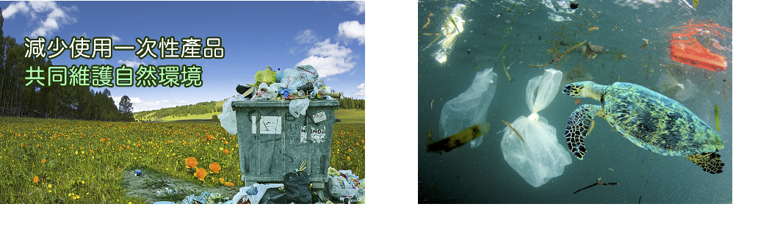
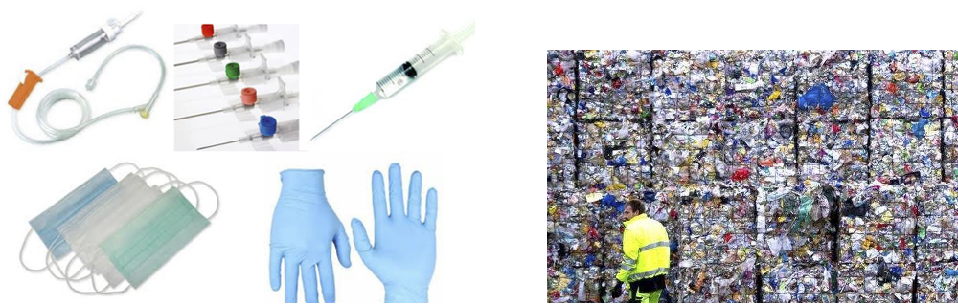

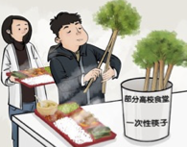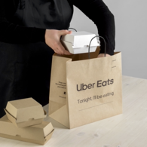

Handout 4: Text Graphic Organizer

Conversation #1
甲： | ____ positive | ____ negative | Example(which product)  Evidence:
乙： | ____ positive | ____ negative | Example(which product)  Evidence:

Conversation #2
甲： | ____ positive | ____ negative | Example(which product)  Evidence:
乙： | ____ positive | ____ negative | Example(which product)  Evidence:

Conversation #3
甲： | ____ positive | ____ negative | Example(which product)  Evidence:
乙： | ____ positive | ____ negative | Example(which product)  Evidence:

from Conversation #1-3
一次性产品 | 甲 | 好处
 |  | 坏处
 | 乙 | 好处
 |  | 坏处

Handout 5: Extensive Reading Material #1 and Activities
Article 1 -- Topic: 环保从购物袋开始 (Modified) (Level: IH to AL)
原文：https://gloss.dliflc.edu/LessonViewer.aspx?lessonId=22888&lessonName=cm_env314&linkTypeId=0
Note: 标黄部分解释：黄色的为生词，尽量给出上下文，让学生可以猜词义。

环保从购物袋开始
中国正在解决到处都是塑料袋垃圾的问题。免费提供塑料购物袋的现象很快就会成为历史。
从6月1号开始，中国的购物者得自己花钱买塑料袋。政府禁止工厂生产质量很差的很薄的塑料袋，也禁止在超市里使用这种塑料袋。商店还是可以使用质量好的耐用的塑料袋，但是购物者得自己花钱买。政府的网站提倡购物者多用环保袋，以减少塑料袋对环境造成的污染。
中国在10多年前开始使用塑料购物袋，所以中国消费者已经习惯了商店免费提供塑料袋的做法。他们现在使用极多的塑料袋，每天平均使用大约30亿个。目前，大量用过的塑料袋填满了垃圾场，污染了河流和环境。
环保人士非常支持政府的做法。北京绿色和平组织的虞鑫说，少用塑料袋需要大家都行动起来。他说，空气污染、水污染，塑料产品造成的白色污染是人们每天都要面对的中国巨大的环境问题，但是人们常常忘记，自己可以帮助减轻环境污染问题。
虞鑫说：“这会要求人们在他们每天的生活中改变一点自己的生活方式。比如，他们可以停止使用塑料袋，少用一次性筷子，或者多用节约能源的灯泡；他们可以更多地使用公共交通工具，等等。所以，我们认为这是个好消息。”
世界上只有为数不多的几个国家和地区禁止使用塑料袋。在亚洲，台湾和孟加拉国禁止使用塑料袋。香港和澳大利亚正在讨论应该怎么做，以减少塑料袋对环境的污染。

Activity 1: 扩大词汇量、猜词义、猜文章内容
Scan the text and circle the following words in the text. Then categorize these words into environmentally related and shopping related words.
垃圾场、环境、免费、环保、塑料袋、消费者、购物者、购物袋、超市
跟环境有关的词  Environmentally related words | 跟购物有关的词  Shopping related words
Answer key: 跟环境有关的词（垃圾场、环境、环保、塑料袋）；跟购物有关的词（免费、塑料袋、消费者、购物者、购物袋、超市）

Activity 2: 段落大意、预测信息、整理文章架构
Determine the main focus of the report. Match each paragraph (left) with its main idea (right).
- 中国正在解决到处都是塑料袋垃圾的问题。免费提供塑料购物袋的现象很快就会成为历史。  - 从6月1号开始，中国的购物者得自己花钱买塑料袋。政府禁止工厂生产质量很差的很薄的塑料袋，也禁止在超市里使用这种塑料袋。商店还是可以使用质量好的耐用的塑料袋，但是购物者得自己花钱买。政府的网站提倡购物者多用环保袋，以减少塑料袋对环境造成的污染。  - 中国在10多年前开始使用塑料购物袋，所以中国消费者已经习惯了商店免费提供塑料袋的做法。他们现在使用极多的塑料袋，每天平均使用大约30亿个。目前，大量用过的塑料袋填满了垃圾场，污染了河流和环境。  - 环保人士非常支持政府的做法。北京绿色和平组织的虞鑫说，少用塑料袋需要大家都行动起来。他说，空气污染、水污染，塑料产品造成的白色污染是人们每天都要面对的中国巨大的环境问题，但是人们常常忘记，自己可以帮助减轻环境污染问题。  - 虞鑫说：“这会要求人们在他们每天的生活中改变一点自己的生活方式。比如，他们可以停止使用塑料袋，少用一次性筷子，或者多用节约能源的灯泡；他们可以更多地使用公共交通工具，等等。所以，我们认为这是个好消息。”  - 世界上只有为数不多的几个国家和地区禁止使用塑料袋。在亚洲，台湾和孟加拉国禁止使用塑料袋。香港和澳大利亚正在讨论应该怎么做，以减少塑料袋对环境的污染。 | A.塑料袋造成的污染  B.中国正在解决塑料袋垃圾的问题。  C.人们应该改变自己的生活方式。  D.世界上有的国家禁止使用塑料袋。  E.环保人士认为大家都要行动起来。  F.政府禁止工厂生产质量差的塑料袋，提倡多用环保袋。

Answer key: 1-B, 2-F, 3-A, 4-E, 5-C, 6-D
Activity 3: 图示化呈现文章 Visualize your reading with pictures

Group work:
1. Each student will be given a paragraph and will find a picture that best represents the content of the paragraph.
2. Each student will retell your passage (with as many details as possible) to your group members.
3. After hearing everyone’s paragraph, determine the sequence of the pictures (paragraphs). Why do you decide to go with this order? Do any connective words or internal logic of the passage help with the decision?

Example:
文章第二段：
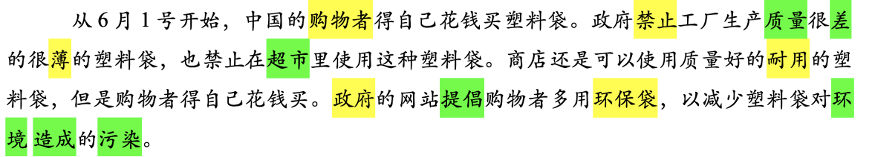
第二段图片：
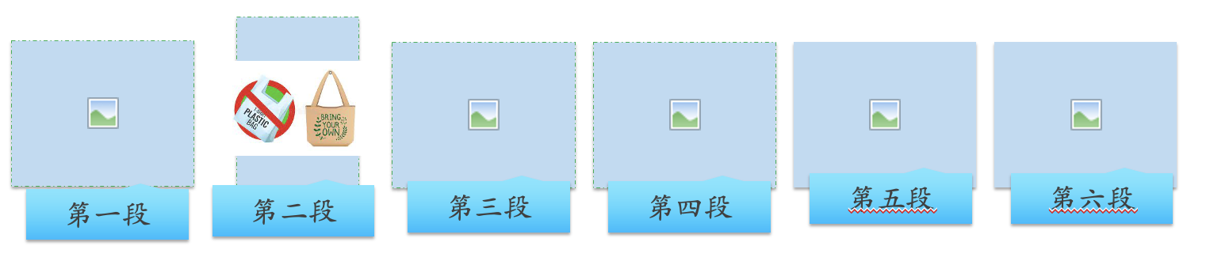

Handout 6: Extensive Reading Material #2 and Activities

Article 2--Topic: “绿色1小时”的九种方法 (Unmodified) (Level: IM to IH)
原文：https://gloss.dliflc.edu/LessonViewer.aspx?lessonId=24953&lessonName=cm_env083&linkTypeId=0

  - 每天少开1小时空调，减少碳排放*621克，还能减少得空调病的机会。
  - 每天少看1小时电视，减少碳排放96克，对保护我们的眼睛很有帮助。
  - 每天少用1小时洗衣机，减少碳排放180克，衣服攒多了再洗，还能减少水浪费。
  - 每天少用1小时电脑，减少碳排放190克，多和家人聊聊天，不会对网络游戏上瘾！
  - 每天少开1小时车，减少碳排放22000克，建议骑车或步行，也可以锻炼身体。
  - 每天拔掉电视插头1小时，减少碳排放86克，让电视深度睡眠吧。
  - 每天外出散步1小时，减少碳排放2254克，呼吸户外的新鲜空气。
  - 每天关灯1小时，少用一度电减少碳排放785克，外出时一定要关灯。
  - 每天1小时不坐电梯，少坐一层减少碳排放218克，爬爬楼梯更健康。

* 碳排放(tàn páifàng: carbon emission): 二氧化碳的排放(carbon emission) is the key phrase in this lesson, it is abbreviated as 碳排放.

FYI: 低碳生活”(low-carbon life)，是指人类生活作息时所耗用的能量要尽力减少，从而降低碳特别是二氧化碳的排放量，减少对大气的污染，延缓生态恶化。主要是从节电、节气和回收三个环节来改变生活细节。A low carbon lifestyle is a means of environmental responsibility toward life, and it also allows for sustainable development. A sustainable green lifestyle advocates a low carbon life, low energy, low consumption and low expenses, thereby cutting CO2 emissions. A low carbon life means a return to innocence; not only is the cost of living low, but the lifestyle is also healthier and more natural.

Activity 1: (work in pair) 图示化呈现文章内容
Use a bar chart to show how much carbon emissions can each “green activity” reduce.
两人一组，用柱状图呈现做每种绿色活动可以减少多少克碳排放。

参考答案：

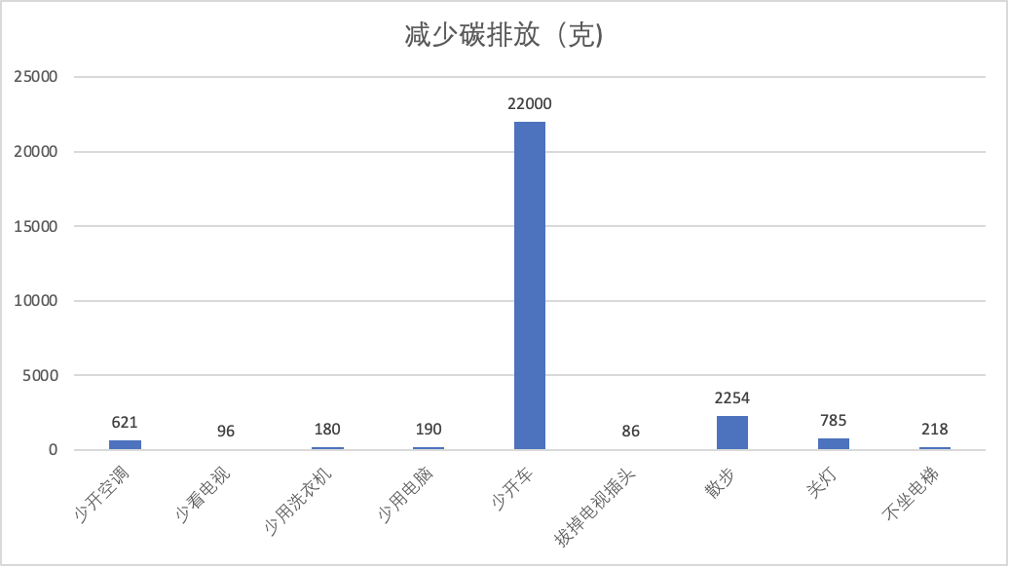

Activity 2: (work in pair)
学生分组讨论，如果排序，自己觉得哪个最容易达成，哪个最难？为什么?
Please work with your partner, and discuss according to your own lifestyle, which one would be the easiest to achieve, and which one would be the hardest. Why? Try to rearrange these nine options into an order.

Activity 3: (work in pair) Write more green activities!
内容没有提及回收、少用塑料袋，如果你要帮忙补充，你会增加什么内容？
As you can see, this list only targeted energy-saving and didn’t mention anything about recycling, protecting natural resources, and reducing white pollution. If you are helping them to create more content, what “green activities” will you add?

Handout 7: 一次性产品--想说爱你不容易 Unit Summative Assessment Instructions, Model Texts, and Role-play Handout
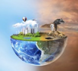
一次性产品—想说爱你不容易
Summative Assessment for Disposable Products
Developed by Chun Ying Lin and Yu (Joyce) Wu
Overview 单元任务介绍
Nowadays, disposable products are almost unavoidable in our daily life. When we purchase coffee, food, or groceries, it is convenient to take paper cups, plastic eateries, or plastic bags. The convenience we are enjoying right now will have devastating effects on our planet in the long run. However, during a global pandemic, disposable products have also met the necessary sanitary requirements. In some circumstances, they are also preferred by customers.
You are asked to participate in a forum discussion on disposable products and environmental protection. The host has invited people from different occupations to share why and how often they use disposable products, the pros and cons of doing so, and their thoughts on the long-term effects on the environment and our lives. After attending the forum, you will advocate the kind of measures that you think should be taken to protect the environment in your university/community/society.

Having the “Will” to success; “Rhode” to success 怎么做？
1. Research Phase 做研究
To prepare for the panel discussion, you will do some research to find out more about the impact of disposable products on our daily life and society.
a. [Interpretive reading] 绿色一小时的九种办法 (IH）
b. [Interpretive reading] 塑料购物袋在中国(AL)
c. [Interpreting listening] YouTube video [一周的垃圾] -配音(IH）
d. [Interpreting listening] Playposit video [一次性筷子的历史和对环境的影响] (AL)

2. Interviews and role-play 采访 & 角色扮演
Interviews: With this knowledge, you will now observe and interview some people from the following categories: self, classmates, university employees (e.g., dining hall employees or managers), restaurant employees or owners. Your questions could be open-ended, but make sure you receive information on how s/he uses/recycles disposable products every day in his/her capacity, and whether there is room for improvement. (IM→ IH) Do you see any differences of views based on their stances? (IH→ AL)

Role-play: After the interviews, you will participate in a role-play in class. Four different groups will discuss using disposable products. (Note: Each student will be assigned to a group, and each group will have a role. You may use some of your interview notes from the interviews as a reference.)
● Role #1. School restaurant manager [You need to consider the school budget. If not using the disposable products, students might need to bring in their own reusable utensils, or the cafeteria must invest more on plates and labor.]
● Role #2. Small restaurants near the school [disposable products are cheap, convenient, and more hygienic….]
● Role #3. Student representative A: [On behalf of students who support environmental protection, you believe that we should enforce environmental protection regulations more strictly for the sake of the next generation. Although it may bring some inconvenience, it is something we need to endure. You also have suggestions for the university to improve the recycling procedure.]
● Role #4. Student representative B: [You agree that environmental protection is important, but the convenience of life should not be ignored. In addition, during the pandemic, you think the use of disposable products is inevitable and safer.]

3. Forum Discussion & Posters on a public-facing website and social media: Our views and advocated actions! 我们的看法和倡议
Now you’ve had a chance to further engage with the topic by hearing different viewpoints and stances. You are ready for the Forum Discussion! What are your current views on the pros and cons of disposable products? We will share our views via oral presentations and will also design posters for our advocated actions.
a. Forum Opening: Story narrator [narration+ description]: 甲 & 乙 from the textbook are your friends, and you found that their conversation about the pros and cons of disposable products today would be a great story to start the conversation on this topic . Please narrate their story/conversation from your point of view in your personal blog and our class website. (IM-->IH) (IH→ AL) (refer to your previous assignment!)
Start with “前几天听到了我的室友（甲）和同学（乙）两人对一次性产品的辩论，甲认为……, 乙认为……, 但是我认为他们的观点表达不够完整，我也认为这个话题对我们的下一代很重要，因此今天我们组织一个讨论会。”下面，我们来听听大家的看法。
b. Forum presentations: Stance takers [perspectives + evidence]: Please try to comment on whose view you agree with. Why? And provide one more piece of evidence to support why you support this point of view. Post your presentation scripts on our class website. (IM-->IH) (IH→ AL)
c. Q&A and forum reports: Reporters [summary + evaluative report]: You will ask questions after the presentations and then write a report to publicize the event. Post your reports on our class website. (IH→ AL)
d. Be an advocate! Poster designers: With your partner, design a poster to advocate for measures that should be taken in your community. Post your poster to social media & our class website to raise more awareness! (IM-->IH) (IH→ AL)

Forum Roles and Model Texts Handout
1. Forum Opening  Narrator  [narration+ description] | 前几天听到了我的室友（甲）和同学（乙）两人对一次性产品的辩论，甲认为……, 乙认为……, 但是我认为他们的观点表达都不够完整，我也认为这个话题不但对我们自己的国家，甚至于整个世界和我们的下一代都很重要，因此今天我们组织一个讨论会。”下面，我们来听听大家的看法。  建议使用：讨厌、质量、经济条件、回收、好处坏处、不如、大量…
2. Stance takers  [perspectives + evidence] | Speaker A: 大家好，今天我来谈谈我对使用一次性产品的看法。我认为，…..，有以下原因：首先……, 其次……, 最后，……。  Speaker B: 谢谢A同学的发言。尽管…., 可是我不同意….。我的理由如下：第一, …...。第二，……。第三，……。综上所述，我的看法是……。  建议使用：丢、人口、资源、回收、污染、重复、分类……
3. Q&A and forum reports  [summary + evaluative report] | 今天XX大学的学生与校园餐厅和附近饭馆的人员就一次性产品对资源、环境造成的影响进行了热烈的讨论。讨论会在____进行，一共有______发言人。A支持……., 因为…..。B认为……, 他/她的原因是(不但…而且…….)。我对这个问题也进行了研究，我发现….。因此，我认为整个世界的人都应该行动起来，保护我们的环境，减少使用一次性产品。（记者______报导）  建议使用：劝、广告、混、捡、想像、回收、保护、浪费、进步…
4. Advocator!  (Poster Credit: Read-On 2015 High School) | Slogan: 保护地球，从我做起！  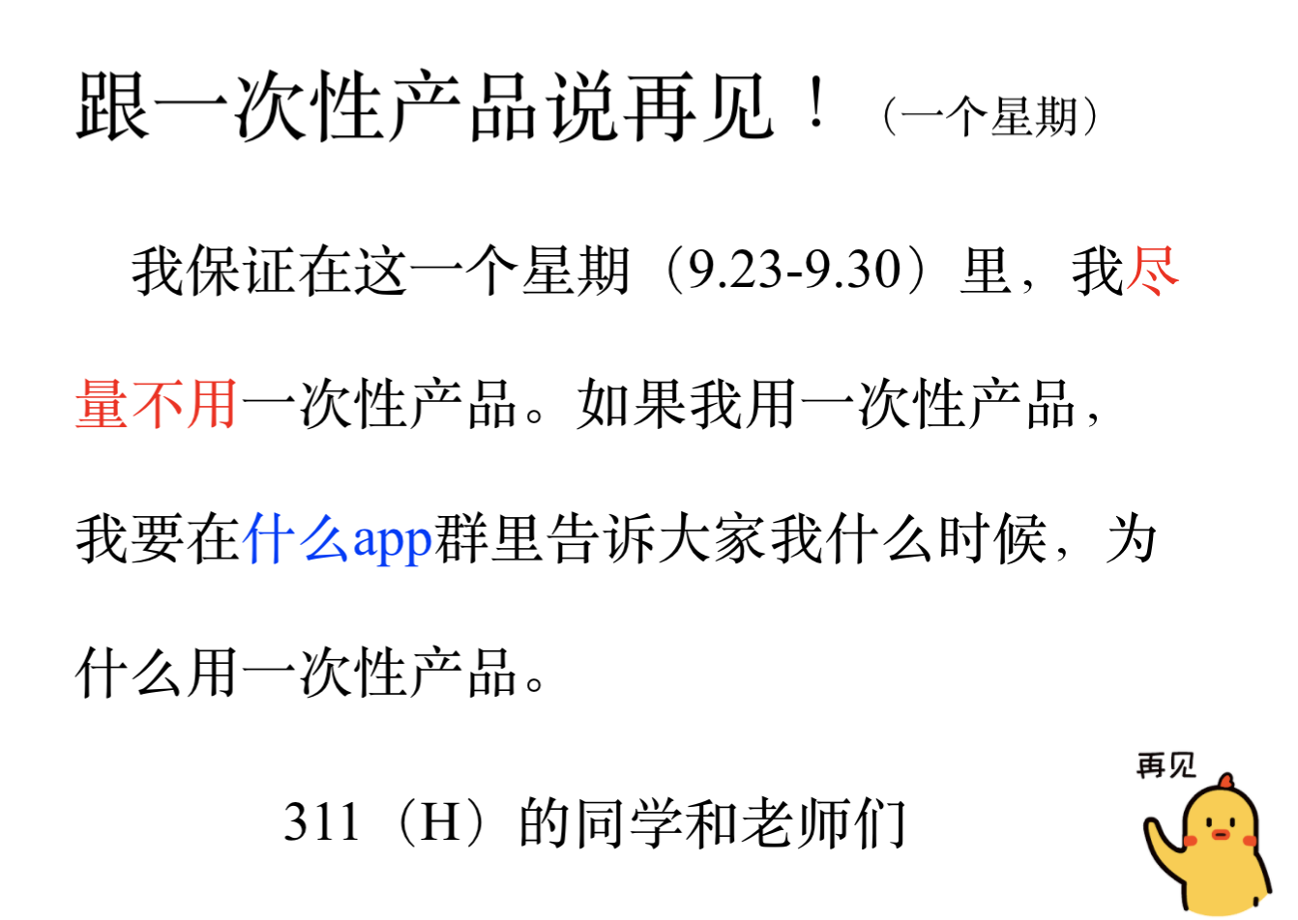  宣传海报: 看下面的例子  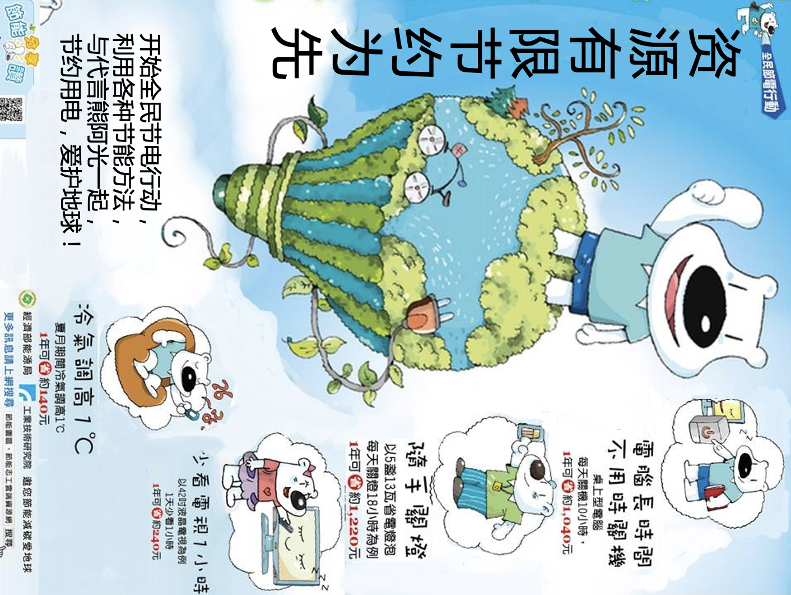  行动宣言：我们要提倡……  (Action Plan Credit: URI CHN311)

Handout for the Role-play Activity

学生餐厅经理 | 学校附近小餐馆老板 | 学生A | 学生B
You need to consider the school budget. If not using the disposable products, students might need to bring in their own reusable utensils, or the cafeteria must invest more on plates and labor.] | disposable products are cheap, convenient, and more hygienic…] | On behalf of students who support environmental protection, you believe that we should enforce environmental protection regulations more strictly for the sake of the next generation. Although it may bring some inconvenience, it is something we need to endure. You also have suggestions for the university to improve the recycling procedure.] | You agree that environmental protection is important, but the convenience of life should not be ignored. In addition, during the pandemic, you think the use of disposable products is inevitable and safer.
考虑成本  如果不用一次性餐具，学生得自带餐具，或者餐厅得多买碗碟，多雇洗碗工 | 一次性产品便宜、方便、卫生 | 支持环保  下一代的环保政策应该更严格  尽管不方便，可是大家应该行动起来，从我做起。  学校应该改善回收做法 | 尽管环保很重要，可是生活方便更重要。  新冠疫情期间，用一次性产品不可避免，而且更安全。

“Will” refers to William Mary; “Rhode” refers to “Rhode Island”.
Students will create a google site for this project.

